PROJECT

STREAMLINNG TICKET ASSIGNMENT FOR EFFICIENT
SUPPORT OPERATIONS

TEAM MEMBERS:
HARI PRIYA S
LOGALAKSHMI M N
KRISHA B
MATHANIKA S

1.INTRODUCTION

  - Project overview:
In modern organizations, customer support plays an important role in maintaining customer satisfaction and service quality. Many companies receive a large number of support requests every day through emails, websites, or help-desk systems.

Managing and assigning these support tickets manually can be time-consuming and may lead to delays, errors, or improper assignment of tasks.

The Streamlining Ticket Assignment for Efficient Support Operations project focuses on improving the process of assigning support tickets to the appropriate team members. The main aim of this system is to automate and organize the ticket assignment process so that customer issues can be resolved quickly and efficiently.

This project helps in categorizing tickets based on priority, type of issue, and available support staff. By using an efficient ticket management system, organizations can reduce response time, improve productivity of support teams, and ensure that customer problems are handled by the right person.

The system also provides better tracking of tickets, monitoring of support activities, and improved communication between support staff and customers. Overall, this project helps organizations deliver faster and more reliable support services.

  - purpose:

The purpose of this project is to improve the process of assigning support tickets to the appropriate team members quickly and accurately. It helps reduce response time, avoid manual errors, and ensure that customer issues are handled efficiently. By automating ticket assignment, the support team can work more productively and provide better service to users.

2.IDEATION PHASE:

2.1 Problem Statement
In many organizations, customer support requests are managed through ticketing systems. These tickets include issues, complaints, or service requests raised by customers. However, in traditional systems, ticket assignment is often done manually or without proper prioritization.
This can lead to several problems such as delayed responses, incorrect assignment of tickets, and inefficient use of support resources.
When tickets are not assigned to the right support agent based on their expertise, workload, or priority level, the resolution process becomes slow and less effective
As a result, customers experience longer waiting times and reduced satisfaction with the service provided.
Another major issue is the lack of an automated system that can categorize and assign tickets intelligently.
Support teams may struggle to track high-priority issues, distribute workload evenly among agents, and ensure that urgent problems are resolved quickly.
Therefore, there is a need to develop a system that can streamline the ticket assignment process. The proposed solution aims to automatically categorize support tickets, prioritize them based on urgency, and assign them to the most suitable support agents.
This will improve response time, enhance operational efficiency, and increase overall customer satisfaction.
The goal of this project is to design and implement a ticket management system that simplifies the support workflow, reduces manual intervention, and ensures efficient handling of customer support requests.

3.REQUIREMENT ANALYSIS

3.1 Requirement Analysis
Requirement analysis is an important phase in software development. It involves identifying and documenting the needs and expectations of users for the proposed system.
For the project “Streamlining Ticket Assignment for Efficient Support Operations,” the requirement analysis focuses on improving the process of managing and assigning support tickets efficiently.

3.2 Functional Requirements
Functional requirements describe the main features and functions that the system must perform.
- The system should allow users or customers to create support tickets by entering issue details.
- The system should store ticket information such as ticket ID, issue description, priority level, and submission time.
- The system should categorize tickets based on the type of issue (technical, billing, general inquiry, etc.).
- The system should automatically assign tickets to the most suitable support agent based on their expertise and workload.
- The system should allow support agents to view, update, and resolve assigned tickets.
- The system should track the status of tickets such as Open, In Progress, and Resolved.
- The system should notify agents when a new ticket is assigned to them.
- The system should allow administrators to monitor all tickets and manage support agents.

3.3 Non-Functional Requirements
Non-functional requirements define the quality and performance of the system.
- The system should provide a user-friendly interface for both customers and support agents.
- The system should ensure fast ticket processing and assignment.
- The system should maintain data security and confidentiality of customer information.
- The system should be reliable and available for users whenever required.
- The system should support scalability to handle a large number of tickets.

3.4 User Requirements
The system will involve the following users:
Customers:
- Able to submit support tickets.
- Able to track the status of their requests.
Support Agents:
- Able to view assigned tickets.
- Able to update ticket status and resolve issues.
Administrator:
- Able to manage agents and ticket categories.
- Able to monitor system performance and ticket reports.

4.DATAFLOW DIAGRAM
Here is the Data Flow Diagram (DFD) content for the project “Streamlining Ticket Assignment for Efficient Support Operations.” You can include this explanation in your project report.

4.1 Data Flow Diagram (DFD)
A Data Flow Diagram (DFD) is a graphical representation that shows how data moves through a system.
It illustrates the flow of information between users, processes, and data storage. In the project “Streamlining Ticket Assignment for Efficient Support Operations,” the DFD explains how support tickets are created, processed, assigned, and resolved.
Level 0 DFD (Context Diagram)
The Level 0 DFD represents the overall system as a single process and shows the interaction between external entities and the system.
4.2 Entities:
- Customer
- Support Agent
- Administrator
Process:
- Ticket Management System
Data Flow:
- Customers submit support requests to the system.
- The system processes the ticket and assigns it to the appropriate support agent.
- Support agents receive the ticket, work on resolving the issue, and update the ticket status.
- The administrator monitors ticket activities and manages system operations.
This level provides a high-level overview of how the ticket management system interacts with users.

4.3 Level 1 DFD
The Level 1 DFD breaks the main process into smaller sub-processes to show how the system works internally.
Processes:
- TicketCreation
Customers submit issues through the system by entering details such as problem description, category, and priority.
- TicketCategorization
The system analyzes the ticket and classifies it based on the type of issue.
- TicketAssignment
The system automatically assigns the ticket to the most suitable support agent depending on expertise and workload.
- TicketProcessingandResolution
Support agents review the assigned ticket, work on resolving the issue, and update the ticket status.
- TicketMonitoringandReporting
The administrator monitors ticket progress, generates reports, and manages support operations.
Data Stores:
- Ticket Database: Stores all ticket details including status and updates.
- Agent Database: Stores information about support agents and their expertise.

Benefits of Using DFD in This Project
- Clearly shows how information flows within the system.
- Helps in understanding the interaction between users and system processes.
- Improves system design by identifying important data handling steps.
- Makes it easier for developers and stakeholders to understand the system structure.

5.PROJECT DESIGN
Project Design
Project design describes the structure and organization of the system. It explains how different components of the system interact with each other to perform the required functions. The design of the project “Streamlining Ticket Assignment for Efficient Support Operations” focuses on creating an efficient ticket management system that automatically assigns support requests to appropriate agents and ensures faster issue resolution.
5.1 System Architecture
The system follows a three-tier architecture, which includes:
PresentationLayer(UserInterface):
This layer provides the interface through which users interact with the system. Customers can submit tickets, support agents can view assigned tickets, and administrators can monitor system activities.
ApplicationLayer(BusinessLogic):
This layer processes the ticket data, categorizes the issues, and performs automatic ticket assignment based on predefined rules such as agent expertise, workload, and ticket priority.
DataLayer(Database):
This layer stores all the system data including user information, ticket details, ticket status, and agent information.

5.2 System Modules
The system is divided into several modules to ensure organized functionality.
1.UserManagementModule
This module manages the registration and authentication of users such as customers, support agents, and administrators.
2.TicketCreationModule
Customers can create support tickets by providing details such as issue description, category, and priority.
3.TicketCategorizationModule
The system analyzes the submitted tickets and classifies them based on the type of problem.
4.TicketAssignmentModule
This module automatically assigns tickets to the most appropriate support agent based on availability, expertise, and workload.
5.TicketTrackingModule
Users can track the status of their tickets such as Open, In Progress, or Resolved.
6.ReportingandMonitoringModule
The administrator can view reports, monitor ticket progress, and manage the support workflow.

5.3Database Design
The system database stores and manages all relevant information.
Main Tables:
- User Table: Stores user details such as ID, name, role, and login credentials.
- Ticket Table: Stores ticket information including ticket ID, issue description, category, priority, and status.
- Agent Table: Stores support agent details and areas of expertise.
- Assignment Table: Stores the relationship between tickets and assigned agents.

5.4 Interface Design
The system provides simple and user-friendly interfaces for different users.
- Customer Interface: Used to create and track tickets.
- Support Agent Interface: Used to view assigned tickets and update their status.
- Administrator Interface: Used to manage agents, monitor tickets, and generate reports.

5.5 Security Design
The system includes security mechanisms to protect user data and system resources.
- User authentication using secure login credentials.
- Role-based access control for customers, agents, and administrators.
- Protection of sensitive information stored in the database.

6.ADVANTAGES AND DISADVANTAGES

Advantages
- Faster Ticket Handling – Automatically assigns tickets to support agents, reducing response time.
- Improved Efficiency – Reduces manual work in assigning tickets.
- Better Resource Management – Distributes workload evenly among support agents.
- Improved Customer Satisfaction – Quick response and faster issue resolution improve customer experience.
- Easy Tracking – Helps monitor ticket status and progress easily.

Disadvantages
- Initial Setup Cost – Developing and implementing the system may require time and resources.
- System Dependency – If the system fails, ticket assignment may be delayed.
- Training Required – Support staff may need training to use the new system effectively.
- Complexity – Automatic assignment rules may become complex in large organizations.

7.SCREENSHOTS
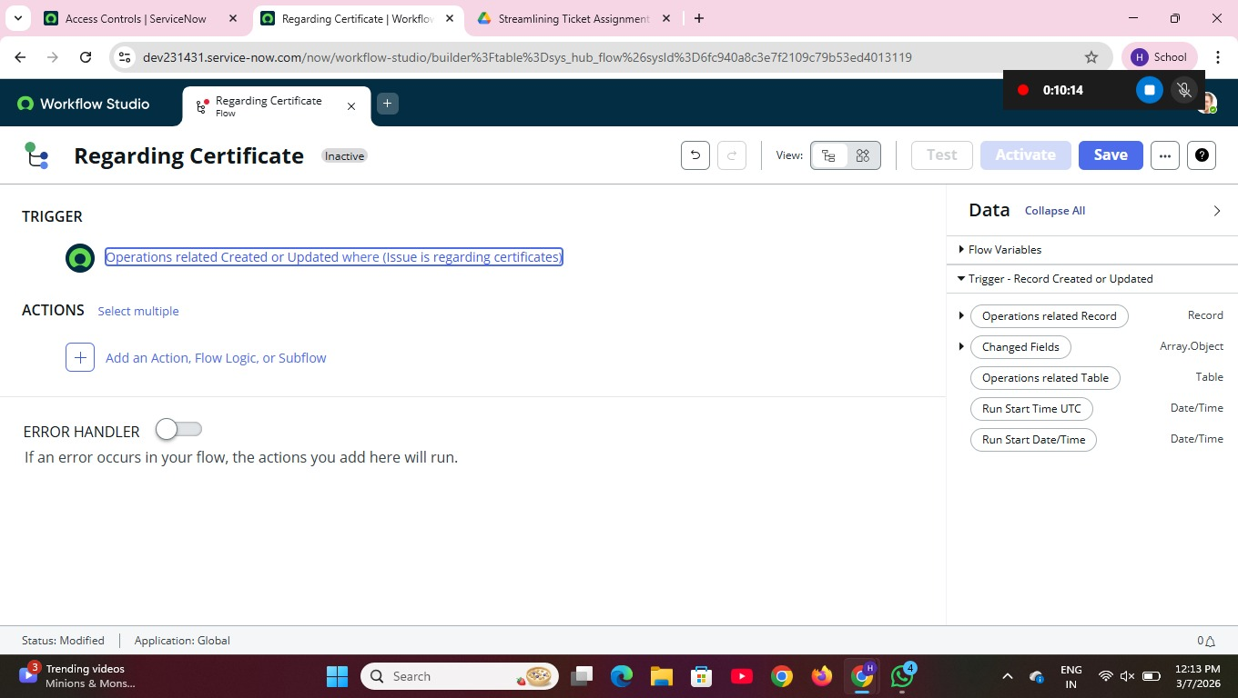

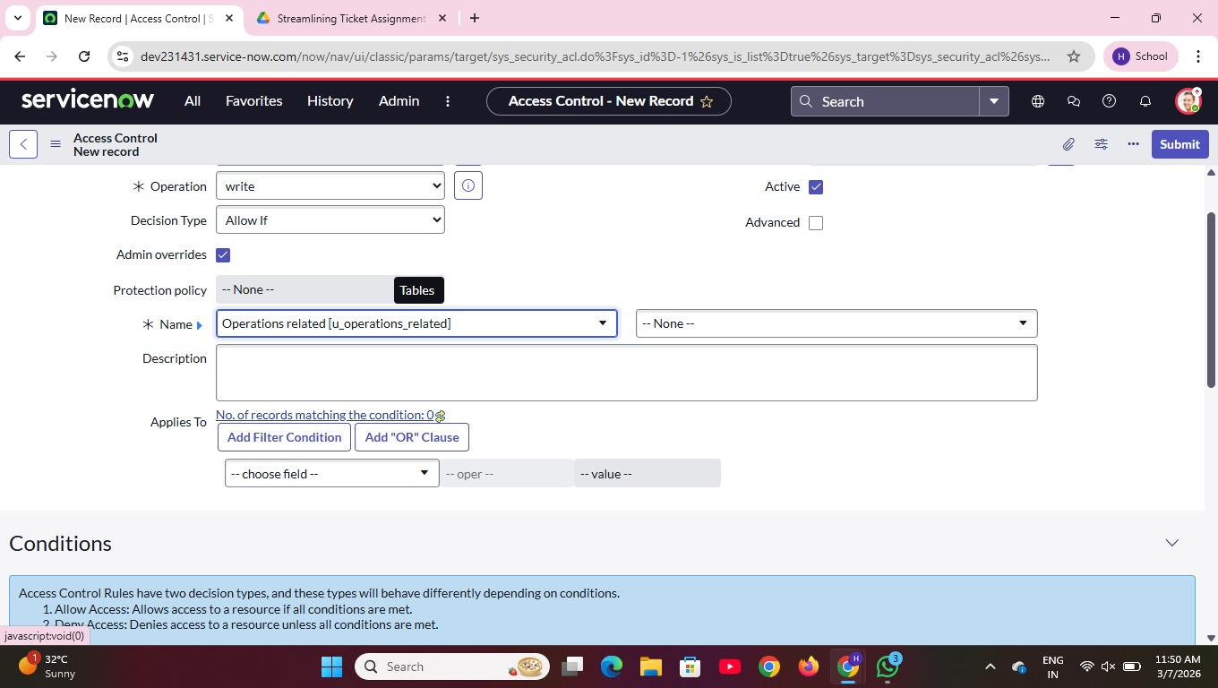

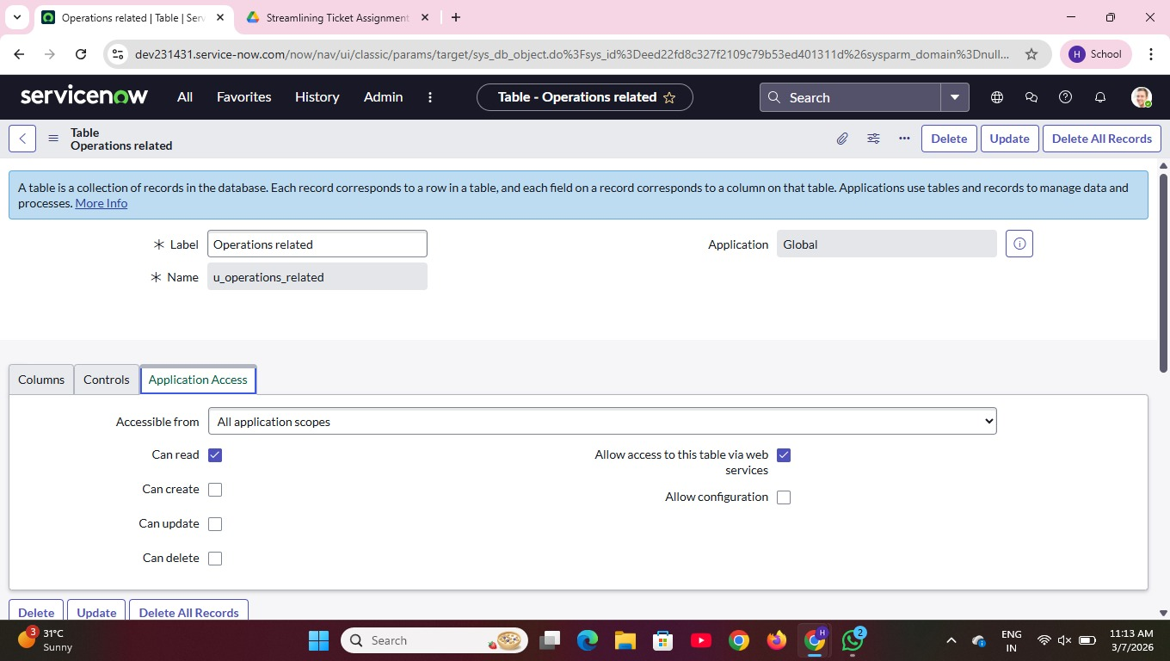

8.CONCLUSION
The project “Streamlining Ticket Assignment for Efficient Support Operations” aims to improve the efficiency of handling customer support requests by automating the ticket assignment process. The system helps in organizing, categorizing, and assigning support tickets to the most suitable agents based on their expertise and availability.
By reducing manual intervention, the system improves response time, balances workload among support agents, and ensures faster resolution of customer issues. This leads to better operational efficiency and increased customer satisfaction.

9.FUTURE SCOPE
The project “Streamlining Ticket Assignment for Efficient Support Operations” can be further improved by adding advanced features and technologies in the future. These enhancements can make the system more intelligent, efficient, and user-friendly.
One possible improvement is the integration of Artificial Intelligence (AI) and Machine Learning (ML) to automatically classify tickets based on the issue description. This will help the system assign tickets more accurately to the appropriate support agents.
Another future enhancement is the implementation of predictive analytics, which can analyze previous ticket data to predict common issues and help organizations prepare solutions in advance.
The system can also be improved by adding real-time notifications through email or mobile applications so that support agents and customers receive updates about ticket status immediately.
Additionally, integrating the system with chatbots and automated support systems can help answer common customer queries without requiring human intervention, reducing the workload of support agents.
In the future, the system can also support cloud-based deployment, allowing organizations to manage support operations from anywhere and handle a larger number of tickets efficiently.
Overall, these improvements will make the ticket management system smarter, faster, and more effective in handling customer support operations.

